1. To estimate price elasticity, we can run a regression using ________ as dependent variable and _______ as independent variable
(a) sales ….... price
(b) ln(sales) …… ln(price)
(c) ln(price) …… ln(sales)
(d) price …… sales

2. A researcher would like to study the effectiveness of advertising in generating store traffic. He records the data from a sample of 20 stores, as shown below.

Store # | Store Traffic | Advertising Dollar
1 | 1000 | 480
2 | 1300 | 710
3 | 400 | 300
4 | 1350 | 800
5 | 700 | 310
6 | 900 | 580
7 | 320 | 100
8 | 1170 | 500
9 | 700 | 690
10 | 125 | 75
11 | 800 | 380
12 | 1200 | 520
13 | 1000 | 700
14 | 1500 | 550
15 | 90 | 40
16 | 1000 | 560
17 | 600 | 190
18 | 450 | 200
19 | 810 | 410
20 | 200 | 110

He then runs a regression using Advertising dollar as independent variable, and Store Traffic as dependent variable. The result of the regression is shown below.

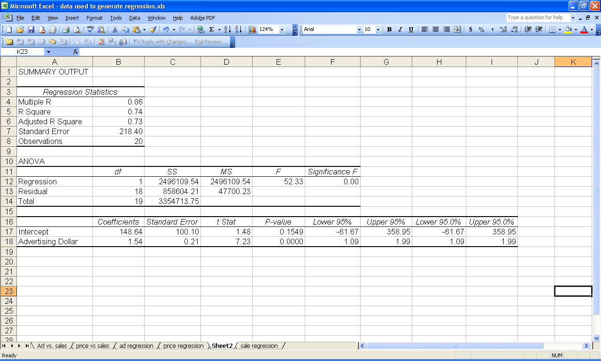

(a) Is advertising dollars a significant predictor of store traffic? Why/Why not? – RSq dekho

(b) How much percent of the variation of store traffic is explained by advertising dollars? RSq = 74%

(c) If Store #16 spends $700 in advertising (instead of $560), what is the predicted store traffic based on the regression equation in (b)?

Y = 148.64 + 1.54*700

(d) Interpret the regression equation by filling in the following sentence

“For each _____Dollar Increase_____ increase in advertising, sales is predicted to ____increase______ by ___1.54_____.”

3. What is the difference between R-Squared and Adjusted R-squared?

R Sq –

Adjusted R Sq – kuch ni hota, bus multivariate linear regression hota hai , it penalizes the addition of more variables which do not contribute significantly to the model – Adjust RSq is always less than R Sq

4. A random sample of 120 students majoring in Accounting in a college of business studies has a mean GPA of 2.7 with a sample standard deviation of 0.4. For the students majoring in Information Systems, a random sample of 100 students gives a mean GPA of 2.9 and sample standard deviation of 0.3. Suppose the college has a reason to believe that the population standard deviation of GPAs of students from these two sets of students is equal. What can we conclude about the average performance of the two groups of students?

  - At 5% level of significance, Accounting students perform better
  - At 10% level of significance, both sets of students perform equally well
  - At 5% level of significance, both sets of students perform differently
  - At 1% level of significance, the Information Systems students perform better

5. Given ANOVA table, with some missing values, please be prepared to fill up the table and answer a few questions based on the completed ANOVA table.

6. Know how to compute P-Value for a test statistic using either tables or Excel or any other software.

